Trabuco Hills High School Events
CVAA - SOUTH COAST LEAGUE
TRACK FINALS - 4/29/22

Track and Field - Varsity - CVAA - South Coast League Track Finals - 4/29/22
Fri, Apr 29, 2022 at 4:00 PM
https://gofan.co/app/events/595241?schoolId=CA19067
Event ID: 595241

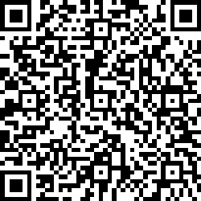

All tickets may only be purchased at gofan.co
(search: Trabuco Hills)

